A concise and informative title suitable for facilitating information retrieval

Running title: a concise title
Running Authors: McGuire and Aydil (or McGuire et al. if more than 2 authors)

Gary McGuire
International Technology Center, P. O. Box 13740, Research Triangle Park, North Carolina 27709
Eray S. Aydil^{a)}
University of Minnesota, Department of Chemical Engineering and Materials Science, 151 Amundson Hall, 421 Washington Avenue SE, Minneapolis, Minnesota 55455

^{a)} Electronic mail: aydil@umn.edu

The easiest way to generate your paper is to use this file and replace the text with the text of your article. For example, you can start typing your abstract here and replace this paragraph. You can delete sections and headings that you will not need. The abstract should be a summary of your article and summary of the new information presented. It should give the important conclusions of the article and any quantitative results of general interest. The abstract is used verbatim in abstracting and indexing services. Therefore, great care should be used in writing it. The abstract should be as specific and as brief as possible and no more than 500 words. Please avoid vague language and acronyms. Number all pages in sequence starting with this page. Page numbers are already inserted in this template.

- INTRODUCTION
This template has been made to help tag the various elements of your text with Word styles in order to expedite production and publication, and assure proper typesetting. Detailed instructions on how to use this template and how to generate your paper are given in the accompanying template instructions file entitled eCEenstructions.pdf. You will also find detailed instructions on how to handle special text elements such as equations, tables, footnotes, etc., in eCEinstructions.pdf. Meticulous attention to the guidelines in eCEinstructions.pdf will help not only the publisher but also the author, since careful preparation is the most important single factor assuring error-free printed text that precisely reflects the author’s intent.
MSWord format is acceptable for article files. However, please note that you may use the built in equation tools of Word 2010, MathType or the older Microsoft Equation Editor 3.0 to write your equations. The use of the older Microsoft Math Editor is discouraged.
The articles should begin with a brief “INTRODUCTION” section where the motivation for the work and background necessary to understand and appreciate the article is discussed. An ideal introduction begins with general background that would be easy to understand by someone who is not a specialist in the area, and becomes increasingly specific. This section should also describe why the work was done and establish novel aspects of what is being reported. The reported work should be put in the context of existing literature and avoid subjective and debatable words such as “first” or “for the first time.” Introduction is also the appropriate section for a brief review of the important and relevant literature. Primary references should be used as much as possible. Please avoid referencing low circulation proceedings or conference abstract booklets. Classic and seminal papers and review articles that introduce key issues in the field are also appropriate references and should be used to guide the novice reader who wishes to learn more about the field. For very long articles, a paragraph that guides the reader through the organization of the paper may be useful and should also be included here.
The authors are responsible for the accuracy of the references. All names, dates, titles, abbreviations, and volume and page numbers should be double-checked before submission. All entries in the reference section must be cited in the text. The list of works cited should appear at the end of the body of the article without a heading. References should be numbered in the order of their first mention in the text. The citation may be used with or without the author’s name: “… it has been shown by Johnson⁵ that …” or “… experiments with calcium,⁶ potassium,⁷ and strontium⁸ have shown….” Several references may be cited together, the numbers being separated by commas: “several recent investigations^{7,9,15} indicate….” If three or more consecutive references are cited together, an en-dash should be used between the lowest and highest reference numbers: “… while others^{10–14} show that….” See the references at the end of this article for style. Please abbreviate journal titles. References should be styled using References style. Do not use word function Insert/Endnotes.
- EXPERIMENTAL
Please organize the body of the paper using first level headings such as “EXPERIMENTAL”, “EXPERIMENTAL SET UP AND METHODOLOGY”, “MODELLING”, “THEORY”, “OBSERVATIONS”, “RESULTS”, “DISCUSSION”, “RESULTS AND DISCUSSION”, “CONCLUSIONS”, etc. More descriptive headings such as “EXPERIMENTAL SET UP AND METHODOLOGY”, “COMPARISON BETWEEN EXPERIMENTS AND THEORY” are also appropriate and encouraged.
A number of styles have been defined for body text (Para) and headings (Head1, Head2, Head3). Do not type a number in front of headings or try to remove numbering applied by the style. The only styling you should do is proper capitalization and italicizing special characters as required.
  - Second level headings
Use second level headings (style Head2) to further organize each section. For example, in the “MODELLING” section you may delineate “A. Gas phase modeling” and “B. Surface modeling.” In the experimental section you may want to organize your article using various experimental methods you used, etc.
  - Third level headings
For most articles, two-level organization is adequate. In some case it may be necessary to include third level headings (style Head3) for finer organization of ideas. If you need third level headings please use numbers as follows. Following is an example of how a section on device fabrication may be broken down.
    - Gate dielectric deposition
Details of gate dielectric deposition and any data associated with this step would be discussed here.
    - Semiconductor deposition
Details of semiconductor deposition and any data associated with this step would be discussed here.

    - Contacts
Issues related to how to make electrical contacts to the device may be presented and discussed here. Avoid very brief sections under third level headings.
- MODELLING
If your article does not include modeling you do not need to have this section. If your article only contains modeling or theory, then you do not need a section entitled EXPERIMENTAL. You can delete any sections that you do not need from this sample template.
  - Equations
For a display equation, create or import the equation using MathType; you may select the program by choosing Insert/Object and then the appropriate program from the Insert menu (on the Create New tab). Once the equation is inserted, press <Tab> once and enter the equation number (if applicable) in parentheses; afterwards applying the style DisplayEq. Equations should be numbered on the right. All symbols should be defined the first time they appear
When referred to in the text, equations should be cited as Eq. (1), Eqs. (3)–(5); if the word “Equation” begins a sentence, it should be written out in full. If a parenthetical reference to an equation is made, the parenthesis around the number should be omitted, e.g., “A relationship (Eq. 4) can be derived….” A displayed equation should be treated grammatically as part of a sentence, and the text immediately preceding a displayed equation punctuated according to the position of the displayed equation in the sentence. (However, punctuation should not be used within the display equation.) For more detailed instructions regarding equations please see detailed instructions in the eCEinstructions.pdf file.
  - Tables
Tables should not be submitted as graphics, but rather submitted as part of your manuscript (please ensure that there are no links to other data sources in any tables). Tables should be included just after they are introduced in the text and embedded in your paper. Use the styles TableTitle, TableColHead, TableBody and TableFootnote to produce your tables (from the styles menu). Following is an example..
Table I. The elemental composition of films sulfidized on sodal lime glass (SLG) and fused quartz (FQ) as determined by EDS. The standard deviations of four separate measurements at the same location on a nominally phase pure Cu₂ZnSnS₄ (CZTS) film (within the detection limits of XRD and Raman) are ±1.9 at%, ±1.4 at% , and ± 0.6 at% for Cu, Zn and Sn, respectively.
 |  | SLG |  |  |  |  | FQ
T_{s}(ºC) | Cu | Zn | Sn | S |  | Cu | Zn | Sn | S
Precursor | 50 | 18 | 32 | 0 |  | 49 | 21 | 30 | 0
100 | 50 | 19 | 31 | 0 |  | 50 | 23 | 28 | 0
200 | 45 | 27 | 24 | 4 |  | 42 | 24 | 26 | 8
300 | 34 | 6 | 11 | 49 |  | 31 | 11 | 9 | 49
400 | 24 | 13 | 13 | 50 |  | 27 | 10 | 14 | 49
500 | 25 | 12 | 14 | 49 |  | 25 | 11 | 14 | 50
600 | 25 | 13 | 13 | 49 |  | 27 | 10 | 14 | 49

  - Figures
Figures should be prepared with care and embedded in the text when they are first discussed. Please prepare illustrations in the final published size, not oversized or undersized. Size your illustrations 3-3/8" wide for single column and 6-3/4" wide for double column figures. Submit each illustration at the final size you wish it to appear in the journal. The standard is 8.5-cm maximum width (3-3/8” or 20.5 picas) for one column. Ensure a minimum of 8-point type size (2.8 mm high; 1/8” high) and that line weights will be 0.5 points or greater in the final published size. Avoid inconsistencies in lettering within individual figures, and from one figure to the next. Please ensure that the production quality figures are at least 600 DPI. Each figure should include all parts of the figure. For example, if Figure contains three parts (a, b, c), then all of the parts should be on the same page. All the panels in multipanel figures should be labeled as a, b, c, etc. Please do not use "top", bottom", "left", "right", etc. The labels should be in one of the corners and clearly visible. Each panel should be described in the figure caption with reference to these panel labels. Please consider your panel layout carefully and keeping in mind that most figures are published in single column width (3 3/8" wide). If you need to publish any figure as double column please prepare them 6 3/4” wide and let us know in your cover letter, which figures you wish to publish as double column. Figure 1 is an example of a figure that would be published as single column. Figure 2 is an example of a figure that would be published as double column. In some cases it may be better to arrange the panels on multipanel figures vertically rather than side by side. This would avoid them becoming unreadable when reduced to single column width. Color online is free and use of color is encouraged. However, please try to choose the symbols and line types for your plots such that when printed or viewed in black and white the readers can still distinguish the data. Use of color is still encouraged. If you use color in a figure please insert (Color online) at the beginning of that figure caption. Fig. 1 (Color Online)....
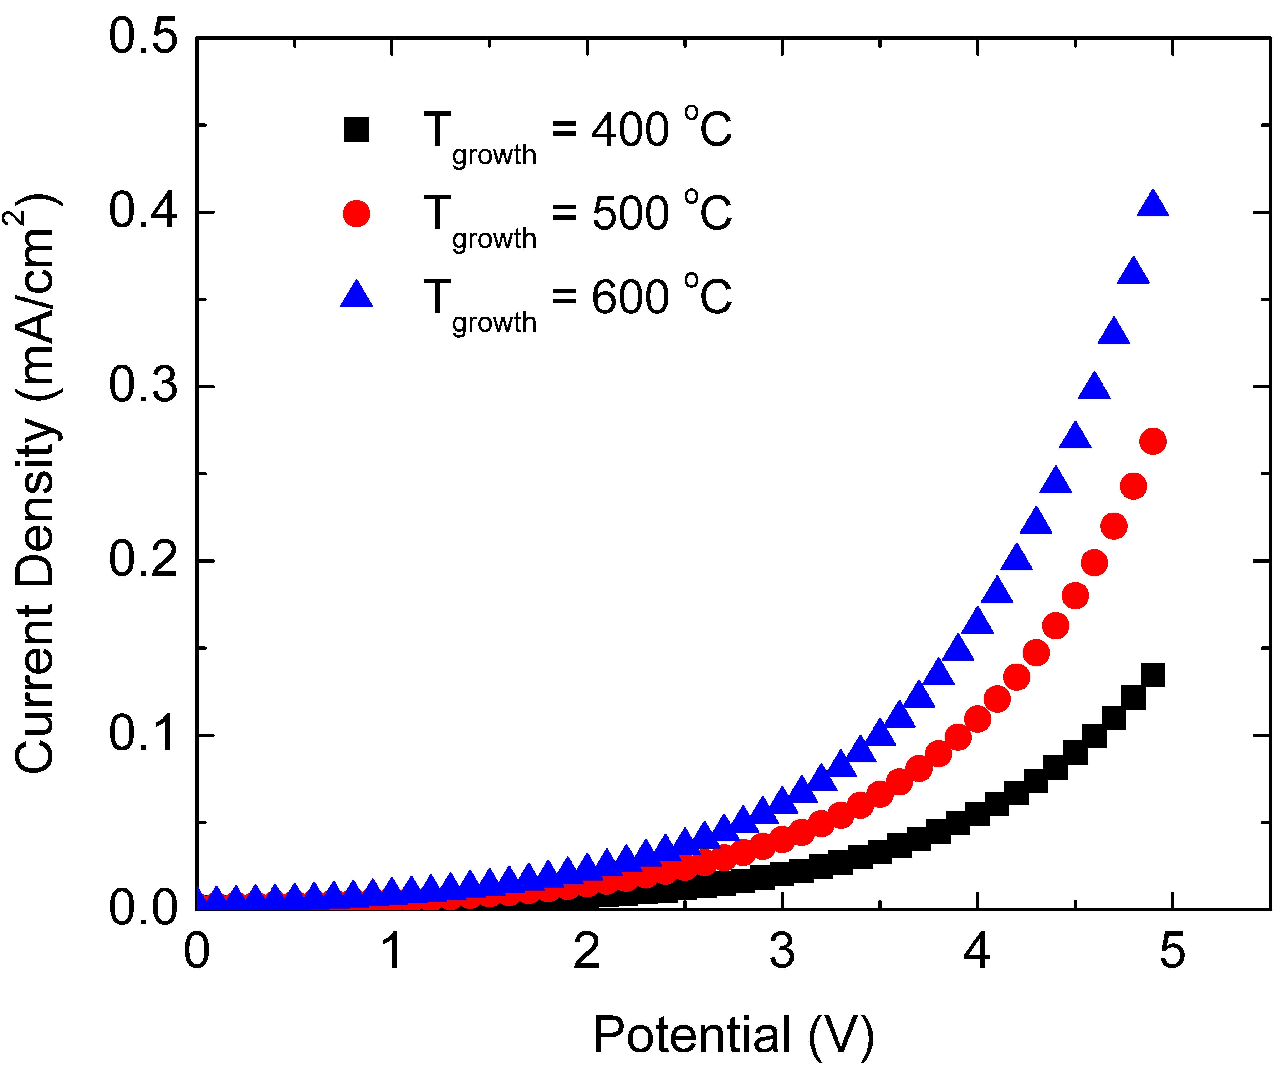
Fig. 1. (Color online) Current-voltage characteristics of diodes made from films grown at three different temperatures. This is an example of a figure that would be published as single column. It is approximately 3 3/8” (8.5 cm) wide.

Once a paper is accepted, separate figure files will be required for final production by the American Institute of Physics (AIP) who prepares the proofs. At this final stage, individual figure files should be submitted and in one of the following formats: PostScript, EPS, TIFF or production- ready PDF (Creating a Production-Ready PDF image) files. The AVS Publications Office encourages authors to embed the figures into the text file and to go ahead and submit the separate figure files at the time of submission or revision.
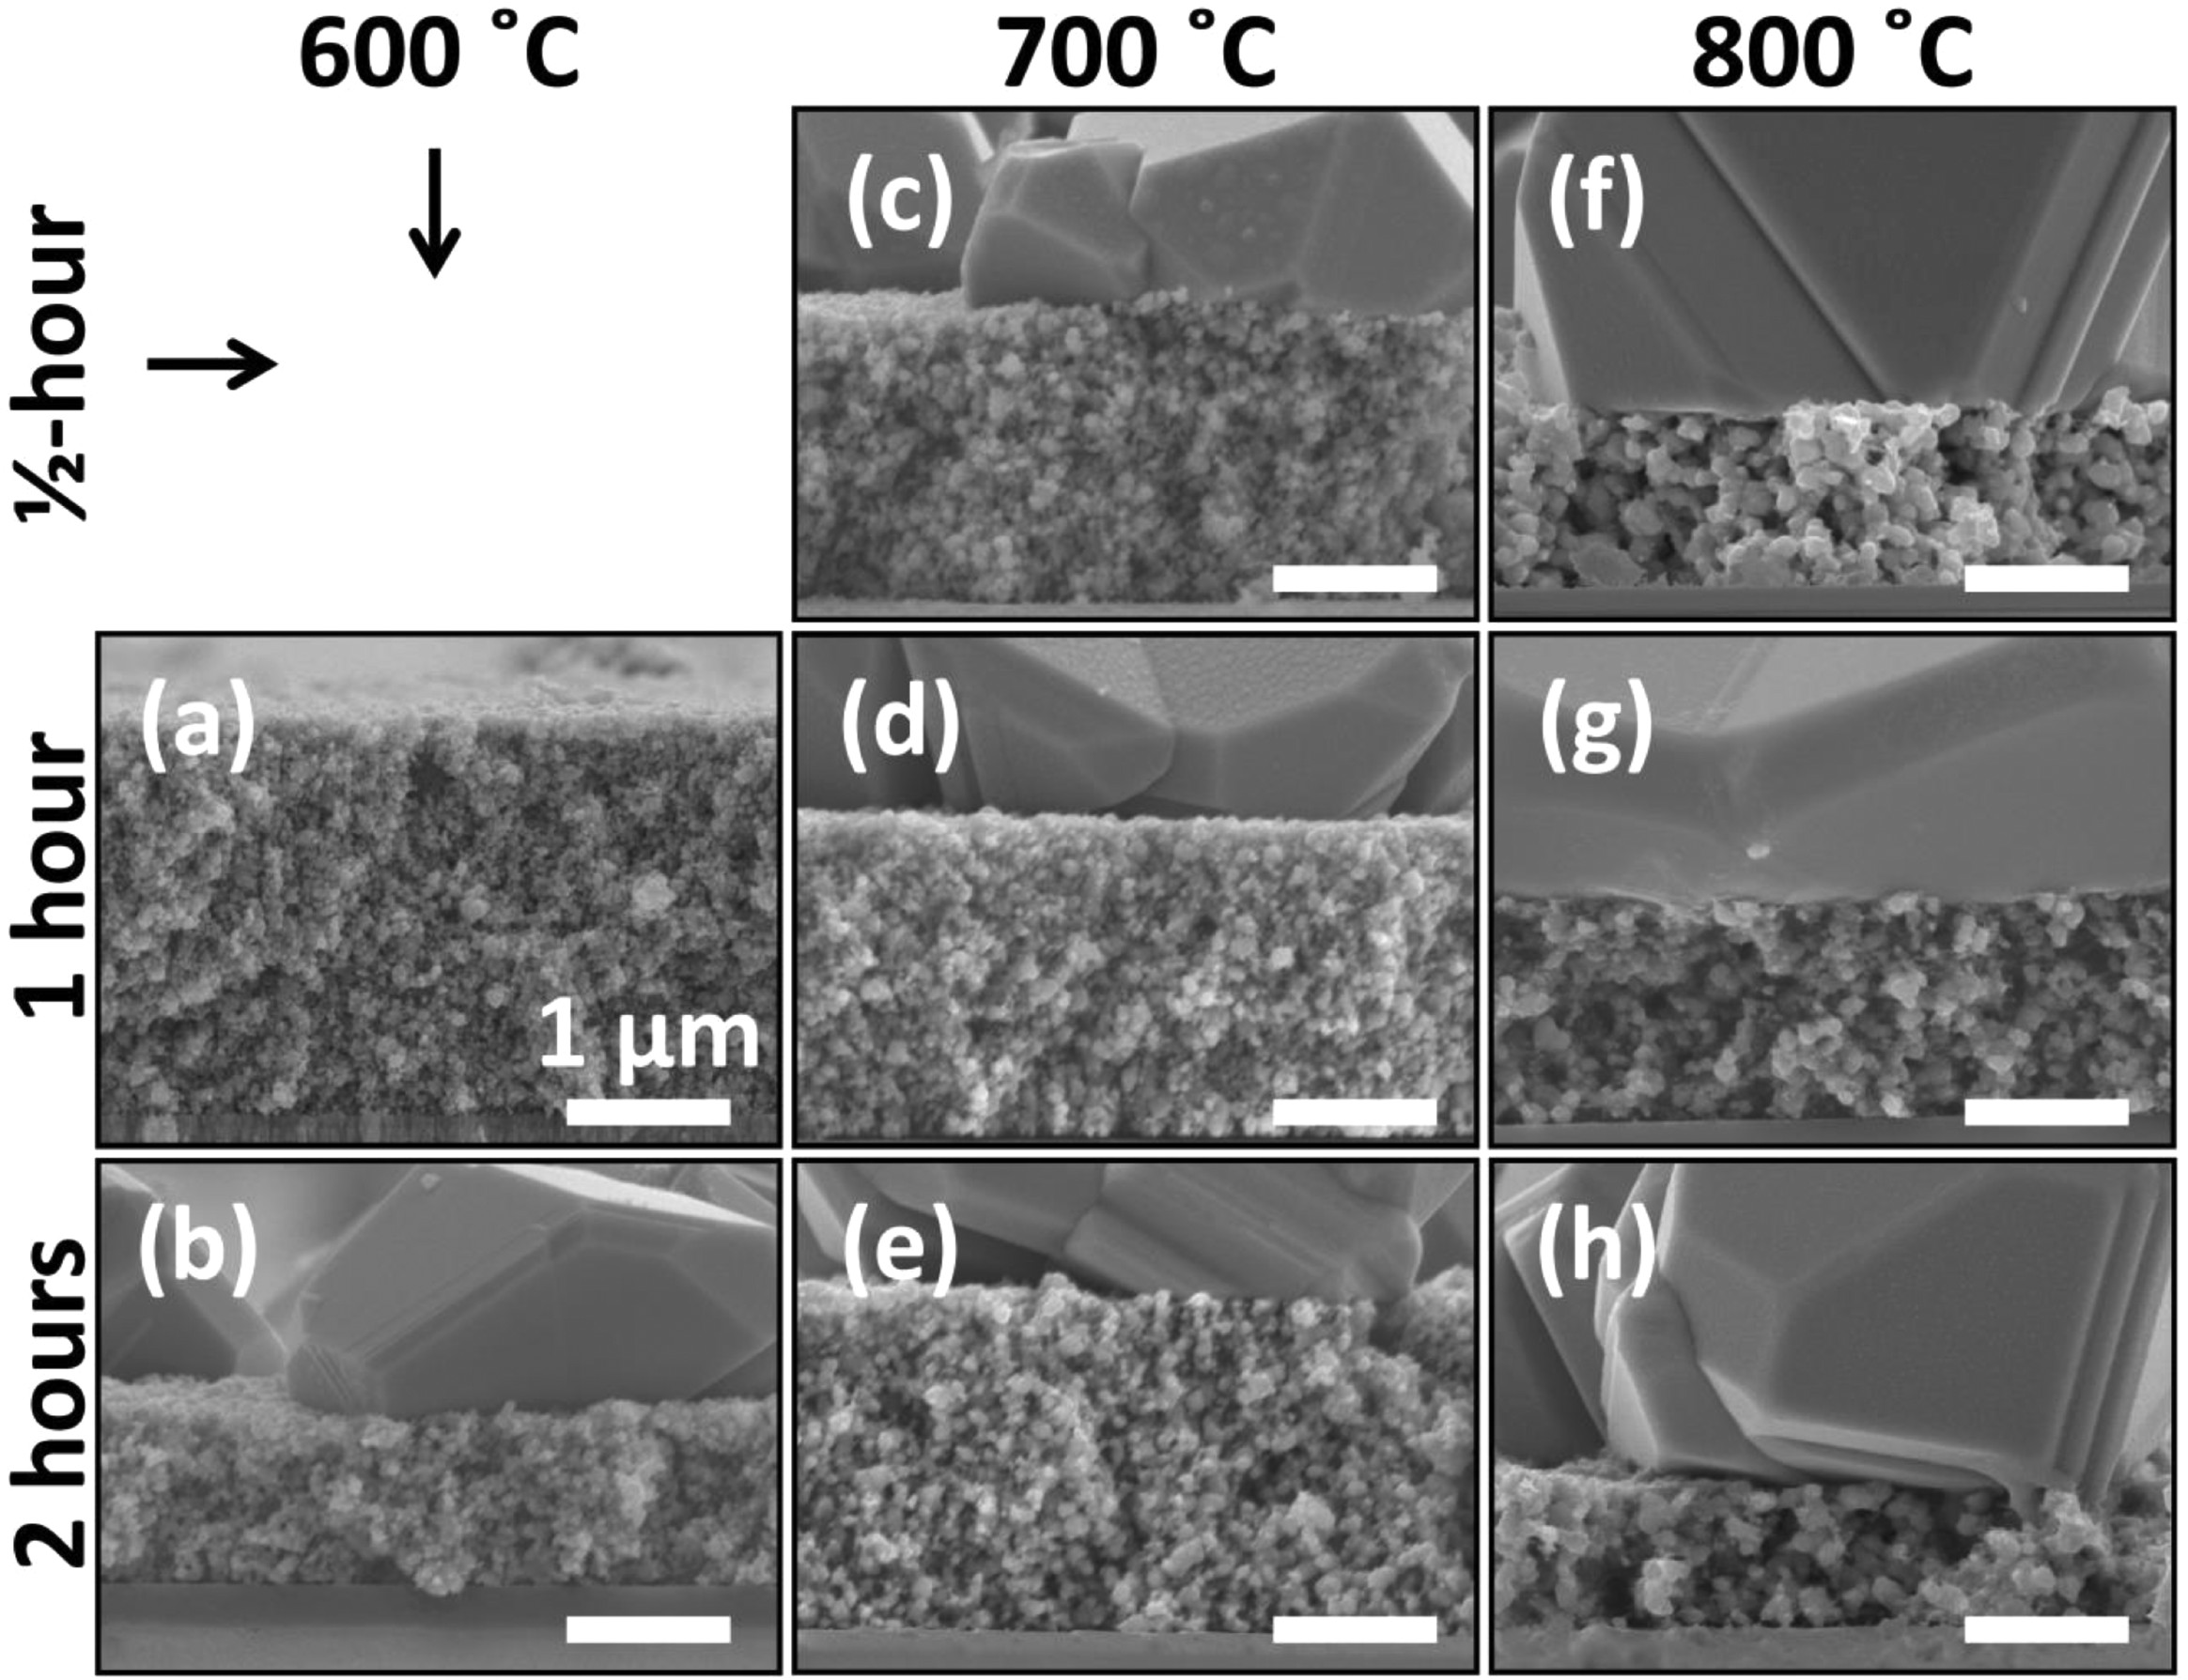
Fig. 2. This is an example of a figure prepared for double column publication. Cross-sectional SEM images of copper zinc tin sulfide films after annealing at (a, b) 600 °C, (c-e) 700°C, and (f-h) 800 °C for (c,f) 30 min, (a,d,g) 1 h, and (b,e,h) 2 h. All scale bars are 1 μm.
Figure 1 is an example of an embedded figure with a caption. Figure captions should be concise but complete. Please use punctuation and complete sentences. Please use FigCap style for figure captions. If presenting experimental data you may want to summarize the experimental conditions. If presenting modeling or theoretical results you may want to include the values of the parameters. All micrographs and photographs should have a scale bar and scale. All graph axes should have a title and units, preferably in parenthesis. Legends should be as descriptive and as brief as possible. Please avoid cryptic legends, sample numbers, etc. If you must use sample numbers, symbols or abbreviations please define them in the figure caption.
- RESULTS AND DISCUSSION
  - Result A
Use secondary headings suitable for presenting the results of your article. In the results and discussion section, it may be helpful to organize your results by major points you wish to communicate. In these cases it may be helpful to think of the second level headings as brief newspaper headlines that quickly communicate a particular result. For example, “Persistent photoconductivity ” or “Chlorine plasma etches silicon,” etc.
  - Method B
Alternatively, you can organize the results and discussion section by method used to arrive at conclusions, for example, “Auger spectroscopy results,” “Current-voltage measurements,” etc. Whatever organization method you choose, the main goal is to help the reader get the most out of your article.
  - Discussion
If appropriate, you can follow the results and observations with a discussion in a section entitled Discussion. Alternatively, such discussion is included with the results above.
- SUMMARY AND CONCLUSIONS
Please provide a concise summary of what was done or studied. Summarize what was learned and concluded. A few sentence on future perspectives or remarks on next steps for research in the area may also be appropriate here. Please do not repeat the abstract verbatim.

ACKNOWLEDGMENTS
Acknowledge grants and other people who have contributed to the work (other than authors) here. Please be concise. Acknowledgements text should be styled as AckText. Acknowledgement title should be styled as AckHead.

¹D. A. Oulianov, R. A. Crowell, D. J. Gosztola, I. A. Shkrob, O. J. Korovyanko, and R. C. Rey-de-Castro, J. Appl. Phys. 101, 053102 (2007).
²A. J. Elliot, “Rate constants and G-Values for the simulation of the radiolysis of light water over the range 0-300C,” AECL Report No. 11073, Chalk River Laboratories, Chalk River, Ontario, Canada (1994).
³Y. Tabata, I. Itoh, and S. Tagawa, CRC Handbook of Radiation Chemistry (CRC Press, Boca Raton, 1991).
⁴Y. Young, Physics in Today’s World, edited by A. Newman (Springer, New York, 1999), Vol. 2, pp. 62–68.
⁵J. Nelson, U.S. Patent No. 5,693,000 (12 December 2005).

