An Example Abstract for the International Conference on Electron, Ion, and Photon Beam Technology and Nanofabrication

A. Einstein, C.A de Coulomb
Institute for Nanofabrication, University College, Cambridge, MA 02139
einstein@university.edu

R. Fineman
HAL Laboratory of Quantum Studies, 137 Coupling Way, Pasadena, CA 91109

Abstracts should be supplied in Microsoft Word (.doc) or as an Adobe PDF manuscript. Please use Times Roman, Helvetica or Arial as your font. 12 point or larger fonts should be used throughout, with the title presented in 16 point or larger. Present the title and author list centered, while the paragraphs of the abstract should be left justified. Please ensure that the presenting author's name is underlined in the author list. Please also provide a contact e-mail.

Use margins of at least 1.5 inch (3.81 cm) on both the left and right sides. Abstracts are limited to one page of text. References should appear on the bottom of the first page. A second, optional page with up to four figures may also be included. Please be certain to make a specific reference to the figures, such as to Figure 1. For the printed book of Abstracts, images such as SEM micrographs will be printed with a halftone process, and so you should bear in mind that images will be reduced in quality when printed. Do not submit halftone images, since a double halftoning processes will result in poorer quality.

You MUST use our on-line abstract submission system at www.eipbn.org. Be sure to use the “invited” option for submission if your paper has been invited. Faxed and e-mailed abstracts are not acceptable, but please contact the Program Chair if you find the abstract submission is not working. Late submissions may be considered, but post-deadline papers will be accepted only if they report truly outstanding results. Abstracts will be peer reviewed according to originality of the work, specific results described, and potential impact. Please prepare abstracts carefully and describe accomplishments specifically.

Please bear in mind that your abstract will be formatted for US standard 8.5x11 inch “US Letter” paper. Formatting your abstract for the longer European A4 paper may result in lost text or cropped images. Please ensure that any text in your figures is large enough to read.

Thank you very much for participating in the EIPBN conference.

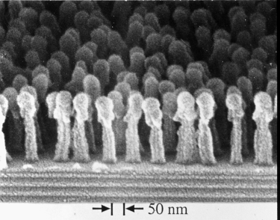

Figure 1: The Debutantes' Ball: At the debutantes' ball, young nano-women gather in their finery at the edge of the stage to weep because none of the nano-boys will dance with them. The micrograph shows an array of 50 nm wide posts with a periodicity of 100 nm. The posts consist of PMMA on top of an antireflection coating. The substrate consists of a 250 nm thick layer of silicon nitride on silicon. Winner of the 1995 “Most Bizarre Micrograph” prize. Submitted by Tim Savas, Massachusetts Institute of Technology.

References should follow standard APS style guidelines. For more, see http://publish.aps.org/STYLE/ms.html

