EIPBN 2022 Request Form for Visa Invitation Letter
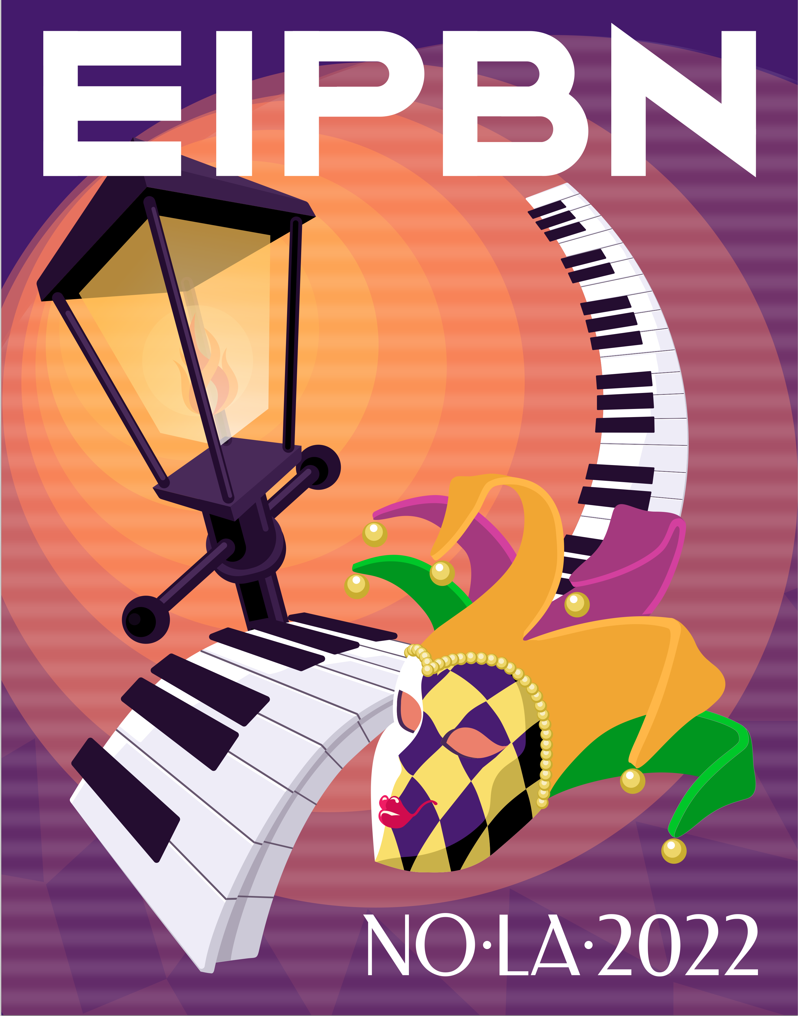
New Orleans, Louisiana
May 31 to June 3, 2022
If you require an Invitation Letter from EIPBN for your US Visa Process,
please fill out this form (one form per person) and e-mail to:
melissaw@widerkehr.com
Personal Information
Prefix (Prof., Dr., Mr., Mz., Mrs.): | First (Given) Name: | MI |  | Last (Family) Name:
Gender: | Date of Birth (MM/DD/YY): |  |  | Nationality:
Affiliation Name (e.g. Company or University): |  |  |  | Passport Number:
Affiliation Department (if applicable):
Correspondence Address: |  |  |  |  | Apt. Number:
City: |  |  |  | State: | Postal Code: |  | Country:
Phone Number (with country code): |  |  |  | Fax Number (with country code):
E-mail address:
Signature
I certify that this information is true and complete to the best of my knowledge.
SIGN HERE: | Signature: |  |  |  |  | Date:

