Startup Contest Application
International Conference on Electron, Ion, and Photon Beam Technology and Nanofabrication

Please submit only one application per venture. Submit through the EIPBN Abstract Submission Portal and choose Startup Contest Submission.
Type over/remove grey text from the completed application. Do NOT delete black text.

1. Venture Name. Initech

2. Team Leader and Primary Contact Information.
M. Curie
Institute for Nanofabrication, University College, Cambridge, MA 02139
einstein@university.edu

3. Additional Team Members.
C.A de Coulomb [1], R. Fineman [2]
[1] Initech, 2 Startup Way, Innovation, CO 12345
[2] HAL Laboratory of Quantum Studies, 137 Coupling Way, Pasadena, CA 91109

4. Describe the business opportunity.

What is the problem that you are trying to solve? How are potential customers currently solving this problem? What are the limitations of current solutions? What is the opportunity to solve pain points for potential customers?

5. Describe your technological solution.

Provide a short description of your product/service. Why do you provide this solution? What is your technology and how does it work? What is the value proposition? What improvement does your technology offer to potential customers? How does your solution improve the user experience or reduce your customer’s pain points?

6. Who is your competition and what are your product differentiators?

Describe the competitive landscape. Which companies currently operate as competitors in your target market? What solution do they offer and how is your solution better? Compared with the competition, what is your competitive advantage and your product differentiators (unique selling points)? Why will potential customers choose to purchase product/technology over the competition?

7. Describe the Market Opportunity. [Optional Section]

What is your target market segment? What is the size of the market? How much of this market do you think you can capture? What assumptions have you made to determine the market capture?

8. Describe the Team. [Optional Section]

What is the team background? Provide a description of roles and responsibilities. What are the team’s strengths and where are the weakness? Why is this a winning team to enable the proposed technology – why you and why now?

9. Describe any traction. [Optional Section]

What are the venture’s accomplishments? Provide details on any measurable traction.

Additional Instruction:
[Please remove the following instructions from completed application]
Abstracts should be supplied in Microsoft Word (.doc) or as an Adobe PDF manuscript. Please use Times Roman as your font. 12 point or larger fonts should be used throughout. Use margins of at least 1.5 inch on both the left and right sides. References should appear on the bottom of the first or second page.

Applications are limited to two pages of text to answer questions 1-9. Questions 1-6 are mandatory for all applicants. All ventures are strongly encouraged to answer Questions 7-9, but these sections are optional. There is no recommend word limit per question; each venture is encouraged to choose how to use the two-page application limit most effectively.

A third, optional page may also be included with up to four figures or links to pertinent information related to the venture. Please be certain to make a specific reference to the figures, such as to Figure 1, in the main application.

To submit your application please use our on-line abstract submission system at www.eipbn.org.

Finalists for the Startup Contest will be notified via email and invited to present in the Startup Session. The Startup Session will consist of a keynote speaker followed by the Startup Contest. Finalists in the Startup Contest will be invited to pitch to the conference audience. The pitch will be presented live. The format for the pitch will be a 3-minute pitch followed by 2 minutest of Q &A with the audience. EIPBN 2024 Startup Contest winners will be announced later on the same day.

Thank you very much for participating in the EIPBN Startup Competition.
Figures and Additional Information

A third, optional page may also be included with up to four figures or links to pertinent information related to the venture. Please be certain to make a specific reference to the figures, such as to Figure 1, in the main application.

Ventures may also use this section to list any awards, recognitions, or accomplishments. Please provide any pertinent links venture website, social media pages, or publicity.

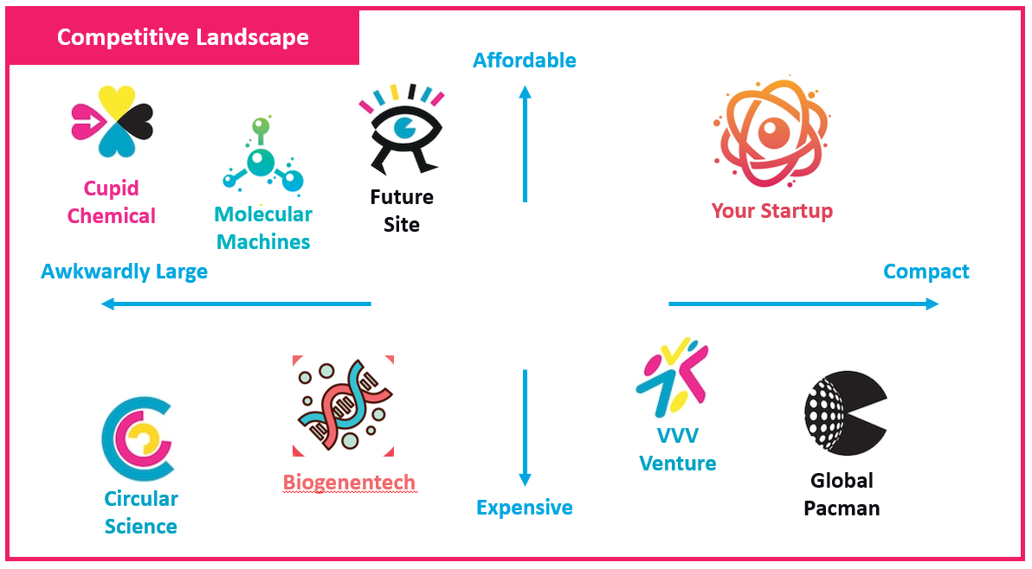

Figure 1: The "Magic Quadrant": This graph is typically included in pitch decks to concisely illustrate how your startup compares to competition based on two significant metrics. The axes are carefully selected so that your startup falls in the top right corner. Rarely will your venture be the sole occupant of this quadrant.

References should follow standard APS style guidelines. For more, see http://publish.aps.org/STYLE/ms.html

