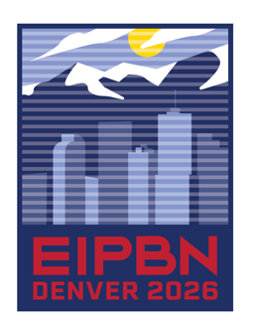
The 69th International Conference on Electron, Ion, and Photon Beam Technology and Nanofabrication
May 26-29, 2026

If you require an Invitation Letter from EIPBN for your US Visa Process,
please fill out this form (one form per person) and e-mail to:
jadams@accent-dmc.com

Personal Information
Prefix (Prof., Dr., Mr., Mz., Mrs.): | First (Given) Name: | MI |  | Last (Family) Name:
Gender: | Date of Birth (MM/DD/YY): |  |  | Nationality:
Affiliation Name (e.g. Company or University): |  |  |  | Passport Number:
Affiliation Department (if applicable):
Correspondence Address: |  |  |  |  | Apt. Number:
City: |  |  |  | State: | Postal Code: |  | Country:
Phone Number (with country code): |  |  |  | Fax Number (with country code):
E-mail address:
Signature
I certify that this information is true and complete to the best of my knowledge.
SIGN HERE: | Signature: |  |  |  |  | Date:

